**U.S. Department of Energy (DOE)  
Clean Energy to Communities (C2C) Program**

Summary of Technical Assistance (TA) Support

|  |
| --- |
|  |
| Icon  Description automatically generatedBuildings |
| Icon  Description automatically generatedClean Power |
| Climate Mitigation and Resilience |
| Cross-Sectoral Justice |
| A picture containing text, clipart  Description automatically generatedJobs and Economic Development |
| Icon  Description automatically generatedMobility |

**DC Infrastructure Academy**

TA Scope

From March through July 2023, the National Renewable Energy Laboratory (NREL) provided technical input on industry best practices around the solar workforce, including research on the solar industry workforce. NREL compiled research and industry best practices around recruiting for the solar jobs of interest, successful apprenticeship programs, and case studies of other industry groups who have successful solar workforce programs. This report looked at research around general strategies as well as specific strategies for targeting women. NREL created a memo of the solar industry workforce research and presented the findings to the Washington, D.C., Infrastructure Academy (DCIA) team. NREL also facilitated discussion between DCIA and other solar workforce groups who are working on similar types of efforts to share best practices and create a peer network.

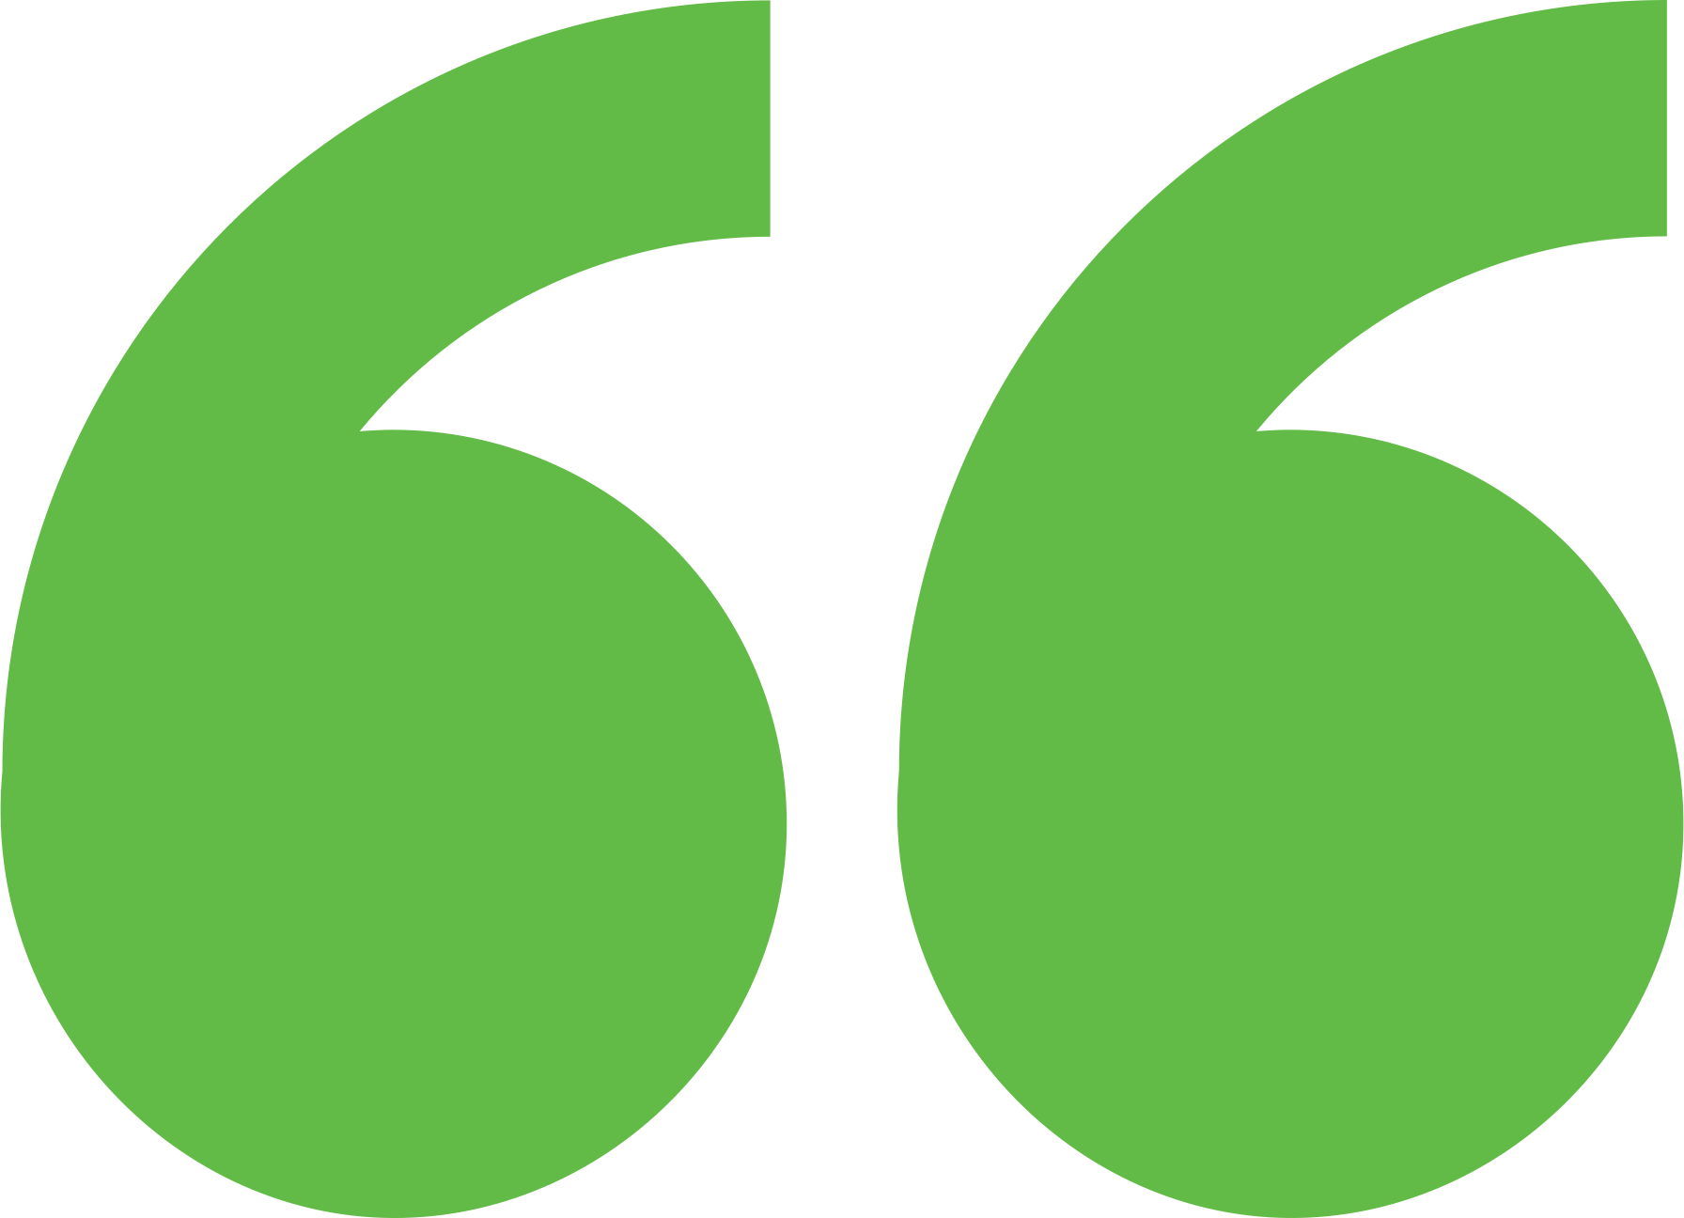 Impact

The technical assistance and engagement with experts will inform future programs and research that are being discussed around workforce development and opportunities for women of color in clean energy.

Background

Photo goes here.

*Delete this box before publishing.*

**Background**

Ann Arbor is a city of approximately 122,000 people located in southeast Michigan. The city and its residents are leaders in sustainability and climate action. Their A2ZERO Climate Action Plan outlines their just transition pathway to community-wide carbon neutrality by 2030. With equity as a focus, they are implementing strategies to improve home energy efficiency (EE) and electrify appliances. Toward this, the city wants to explore community geothermal heating and cooling to serve a variety of building types including rental and affordable housing. The city has applied to DOE’s Geothermal Heating and Cooling Design and Deployment program and garnered the support of City Council to pursue these projects, but they need to understand the concept’s feasibility in order to make a “go, no-go” decision.

DCIA is interested in urban sustainability and the solar workforce. DCIA was experiencing challenges recruiting for renewable energy jobs. DCIA wanted to know what they might be missing in their approach to attract the right people for the solar workforce and careers in solar. This included how to package the opportunity to make it more attractive to workers, connecting trainees to apprenticeships, information about novel or current urban sustainability efforts, and case studies on what other communities have done to connect people to the solar industry. They were interested in research on jobs in solar installation, photovoltaics design, and solar sales. DCIA would like suggestions for a general population as well as specific approaches for targeting women to the solar industry.

Expert Match Team

**Alexandra Kramer**  
Community Lead, Main Expert Match Point of Contact, NREL

**Sika Gadzanku**  
Researcher, C2C Expert Match Program Lead, NREL

Community Team

**Theresa Mason Ford**  
Solar Workforce Development Professional

For more information, visit:  
**energy.gov/eere/clean-energy-communities-program**

August 2024